pro.Ticket Reservation

Task 1

Sponsor: Mahmoud Mohamed Shehata
Business need:
It has happened so many times that you have been waiting on railway station for someone to arrive and you don’t have any exact information about train timing and other stuff. So here we present to you a project on Railway Tracking and Arrival Time Prediction. Using this system user’s can get the information about train timing, and is it on time or not, and other information.
Requirements:
- In this, system will track the train timing at what time train departed from a particular station and pass these timing details to other station’s system where it will display the timing according to train departed from previous station. If system will find any delay in train due to signal it will automatically update the train timing in next station and will be displayed to viewers.
- In this system there is an admin module, who enters the detail about trains and its timing and these details will be passed through internet server and is fetched by the system on other stations, and there is other system that shows train information to the viewers on platform.
- Second system will get all the information of all trains but will automatically select the data that refers to particular station and shows that information on screen. For example if an admin at Alex station enter information about Cairo station Chennai station system will not be effected but Cairo Station system will show the information about train. This system works like – when train is departed late from a station, admin will enter details about departure and its time, and this information goes in real time on internet server and retrieved on other system through internet server and shows the details on screen. Station masters on every station have a login wherein them may update train arrival time at their station when it arrives. This second System is installed on various locations on station for viewers to view the information.
- Admin will add information like train departed from station, expected arrival at destination, delay in the train schedule, etc. This project publishes real-time train schedule events to subscribing multiple client applications.
Constrains:
Time constraint:
The time limit for the project does not exceed one year
Scope constraint:
- Local train ticketing on android projects application can help the customers to save lot of time since they need not wait in queues to get the tickets.
- The details of the seat availability are easily available through the use of this application.
- You can do Mini projects on Android local train ticketing easily through the use of this application.
- This application is useful, reliable, secure and very efficient to use even by the common man with great ease.
- The details of the customers who book tickets are easily storable through the use of this application.
- People can rely on this application without any issue.
- This application can also show the ticket prices recently updated without any difficulty.
- The ticket booked is easily available through this application
Special issues or constrain:

Security and ticket duplication issue.
Railway fare and rates must be updated regularly.

Technical feasibility:
- Familiarity with application: Familiarity is high because are used to using social media apps and risk is medium because some people didn’t use to pay online.
- Familiarity with technology: Familiarity is high because our team do many projects like that.
- Project size: it is large project have more risk

Economic feasibility:
Development cost:
- Consultant fees
- (24,000$)
- Office space and equipment
- (12,000$)
Hardware Requirements:
- 7 PC
(35,000$)
{Hard Disk (1 TB),
Pc Processor (core I 7 10gen)
Mother Board (ROG Maximus),
Speed (3-4 GHz),
RAM (32GB)}
- 10 Device (Smart Phones)
(8,000$)
- Server for database (2,000$)
- Server for communication
(9,000$)
Software Requirements:
- IDE (Eclipse)
(200$)
- Operating System
(200$)
- Supporting Device
- Database development
(15,000$)
- QR Code
(4,000$)

Total 109,400$

Annual cost:
- Check
(10,000$)
- Upgrade
(7,000$)
- Lenience
(500$)
- Salaries
(252,000$)
- User training
(5,000$)
Total: 274,500$
Total: 383,900 $
Tangible benefits:
- Sales
(200,000$)
- Advertisement
(50,000 $)
- Reduction in staff
(40,000 $)

Intangible benefits:
- Productivity
- Improve customer service

Total benefits:
290,000

Cash Flow Analysis:

 | Year 0 | Year 1 | Year2 | Year3 | Year 4 | Total
Total benefit | 0,0 | 290,000 | 350,000 | 440,000 | 560,000 | 1,640,000
Total costs | 109,400 | 274,500 | 300,000 | 334,000 | 367,000 | 1,384,900
Net benefits | (109,400) | 15,500 | 50,000 | 106,000 | 193,000 | 255,100
Cumulative net cash flow | (109,400) | (93,900) | (43,900) | 62,100 | 255,100

Return on Investment (ROI)
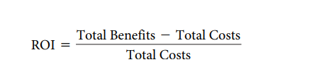
ROI = (1,640,000 – 1,384,900) / ( 1,384,900 )
= 18.42 %

Break Even Point (BEP)
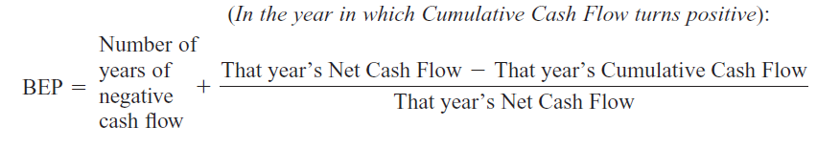
=2+((255,100- 193,000) /255,100)
BEP = 2.24years

Present Value and Net Present Value:
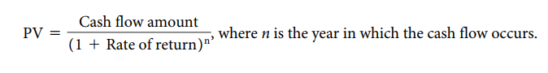
 | Year 0 | Year 1 | Year 2 | Year 3 | Year 4 | Total
Total benefit | 0,0 | 290,000 | 350,000 | 440,000 | 560,000
PV of TB | 0.0 | 263,636 | 289,256 | 330,579 | 382,488 | 1,265,959
Total costs | 109,400 | 274,500 | 300,000 | 334,000 | 367,000
PV of TC | 109,400 | 249,545 | 247,934 | 250,939 | 250,666 | 1,108,449
NPV =
NPV = 1,265,959 - 1,108,449 = 157,510
/////////////////////////////////////////////////////////////////////////////////////////////////////////////////////////////////////////////////

Name of the task |  | Buy server
Start date |  | 1/4/2022
Completion date |  | 11/4/2022
Person assigned to the task |  | Mostafa Ragb
Deliverables |  | Store data
Completion status |  | complete
Priority |  | High
Resources needed
Estimated time | 20
Actual time | 18

Name of the task |  | Gathering information from train station
Start date |  | 1/4/2022
Completion date |  | 10/5/2022
Person assigned to the task |  | Mostafa Khalifa
Deliverables |  | Find out which stations will be on the app and train times
Completion status |  | Complete
Priority |  | High
Resources needed |  | My SQL
Estimated time | 72
Actual time | 68

Name of the task |  | Design UI/Ux
Start date |  | 1/4/2022
Completion date |  | 20/4/2022
Person assigned to the task |  | Mahmoud Shehata
Deliverables |  | interface design
Completion status |  | Complete
Priority |  | High
Resources needed |  | Adobe xd
Estimated time | 25
Actual time | 19

Name of the task |  | Developing
Start date |  | 21/4/2022
Completion date |  | 19/5/2022
Person assigned to the task |  | Mostafa Mohamed
Deliverables |  | Design the front end of APP
Completion status |  | Complete
Priority |  | High
Resources needed |  | Android studio
Estimated time | 70
Actual time | 68.5

Name of the task |  | Test
Start date |  | 20/5/2022
Completion date |  | 30/5/2022
Person assigned to the task |  | Mostafa Hamouda
Deliverables |  | Ensure that there are no errors
Completion status |  | open
Priority |  | High
Resources needed
Estimated time | 10
Actual time | 7

Name of the task |  | coding
Start date |  | 31/5/2022
Completion date |  | 18/7/2022
Person assigned to the task |  | Mostafa Ashraf
Deliverables |  | Design the back end of APP
Completion status |  | open
Priority |  | High
Resources needed |  | Android studio Software
Estimated time | 112
Actual time | 105

Name of the task |  | Test
Start date |  | 19/7/2022
Completion date |  | 27/7/2022
Person assigned to the task |  | Mostafa Mahmoud
Deliverables |  | Ensure that there are no errors
Completion status |  | open
Priority |  | High
Resources needed
Estimated time | 10
Actual time | 8

Name of the task |  | Full Test
Start date |  | 28/7/2022
Completion date |  | 5/8/2022
Person assigned to the task |  | Full team
Deliverables |  | Ensure that there are no errors
Completion status |  | open
Priority |  | High
Resources needed
Estimated time | 12
Actual time | 10

Interviews
First interview (1):
Database Developer Q: What type of System do you want? Should it be online or should
it be desktop application?
Customer Ans: I want the railway reservation system online.
Database Developer Q: What features should this online system have?
Customer Ans: System should be able to reserve or cancel any seat of the
passenger. System should have all the info about the trains.
Customer’s detail should not be taken again and again it should be
saved when the customer first time buys a ticket. System should also
be able to tell the customer’s reservations, fares and concessions etc.
Database Developer Q: As you said passenger can reserve or cancel the ticket. By which
method he should pay for the ticket either by Debit Card or Credit
Card?
Customer Ans: I think both options should be available for the passenger. So
that everyone can enjoy the facility of online reservation system.
 | Stakeholders Conversation
Person interviewed: | mister Ali
Purpose of interview: | to know what the customer need and want
Summary: | - the railway reservation system should be online -application.  - System should be able to reserve or cancel any seat of the passenger.  - System should have all the info about the trains.  Customer’s detail should not be taken again and again it should be saved when the customer first time buys a ticket.  - System should also be able to tell the customer’s reservations, fares and concessions etc.  - credit card and debit card should be available for the passenger. So that everyone can enjoy the facility of online reservation system
Open item: | if anyone wants to pay by cash

Second interview (2):
Hello sir how are you?
- I’am doing well
What are your imagination about the new system?
- I think it’s a big step because it saves a lot of money and time
Do you have any experience with new technology ?
- yes
Do you realize how to utilize or work on (typewriter, PC, drill press, the 3 C’s of selling, SWOT examination, and so forth)? Indeed or no? Clarify.
- Applicant: Yes. I utilized (a typewriter, PC, social media, and so on) in my last work and turned out to be intimately acquainted with it. I additionally found that I did very well with it and came to appreciate utilizing it.
Can you work with our new system ?
- yes I can but I need training
Are you satisfied with this new system
- yes, I think it is a revolution
What are the problems you face in your job daily?
- I face a big challenge with rush hour that I deal with a lot of people that increase making mistakes and I have a problem with money because it is a big responsibility.
What do you think about the current system?
- The current system is old and slow and the railway need new system to afear the huge number

Interviewer:
Person interviewed:
Purpose of interview: | To know the internal problem inside the existed system and repair it .
Summary: | - Some of employees have experience in technology and some of them not  - The employees need training to know how to deal with the new technology  - We need to make the app could bear a large number more and more passengers use railways, and the services become increasingly popular, delays and malfunctions on these networks may also increase. increase the protection, serves to reduce the risk  of any damage can happened, and the consequent damages associated.  - The current system is old and slow and the railway need new system to afear the huge number
Open item:

Third interview (3):
Ui /ux designer
• What are the short- and long-term business goals?
Short goal is to do prototype to see people reaction and long term to do the whole ui/ux
• What is the stakeholder’s role in the company?
• Who are the users?
The customers who travel by train and the employees in the station
• What are a few major competitors?
THAT WE NEED TO COMPLETE THIS PROJECT QUICKLY
• Are there any technological limitations?
NO, WE USE MODERN TECHNOLOGY
• What are a few product concerns?
THAT THE USER COULDN’T DEAL WITH THIS APP And employees also
• What is the stakeholder’s definition of product success?
THAT EMPLOYEES and customers find this app easy to use
Interviewer: | Mahmoud Shehata
Person interviewed:
Purpose of interview: | To make an overall view on the user Interphase and User Experience
Summary: | - WE USE MODERN TECHNOLOGY and there are not technological limitations.  - the first major competitors THAT WE NEED TO COMPLETE THIS PROJECT QUICKLY and without any wrongs.  - product concerns THAT THE USER COULDN’T DEAL WITH THIS APP so my role to make the app easy as possible as to deal with.  - we should make prototype as soon as possible  - we should make a great ux to employees with concerns that this app should be easy to them  - the app has 2 versions one for customers and the other for employee, the employee version should have clear interface and simple form and customer version should be suitable for simple user who hasn’t experience
Open item: | How to drag adv in the app  The prototype of the interface

Fourth interview (4):

Hello Dr/ frank how are you?
I’m doing well
We are here to ask you for some information about our railway system?
Emmm ok you can ask me now
What do you think about our system?
- I am sorry I am not specialist in this field because that required mobile application
Can you advise us what to do?
- I advise you to use flutter technology
Why?
- Because google support this technology and there are a lot of developers use and support and google develop it Periodically
Can you tell us more tips?
- Ok I think electronic payment is difficult, so it must be worked on carefully
Can you tell us how we can make it easy?
- Sorry idk because I didn’t something like that before.

interviewer: | Mustafa Ashraf, Mahmoud Shehata
Person interviewed: | Dr/ Frank Mayor  (Dr in programming in Texas university)
Purpose of interview: | Understand how to build an app
Summary: | - He said that he is not a specialist in programming phone applications.  - he advised to use flutter technology  - He said that the introduction of electronic payment is difficult, so it must be worked on carefully
Open item: | None.
*************

Fifth:

Hello prof Maged how are you?
- I’am doing well.

Can I ask you what programming language should we use?
- I think java is the best choice

What can the system do?
- The system records the attendance, departure and absence of employees.

How can we sort the data?
- to sort employees and customers, we use SQL to sort their data.

Could you tell us more about the system?
- every user(customer) should have account they can access the app because the account is on the database with specific code.

Can you describe how we deal with customer data?
- customer data will be a database, so all customer can get their information from the app.

There is something do you want to add?
- trains information will be saved in disparate database.

Fifth interview (5):
interviewer: | Mustafa Hamouda
Person interviewed: | Dr/ Majed  consultant in programming
Purpose of interview: | obtain technical information for the application.
Summary: | - programming language used for android is java.  - The system records the attendance, departure and absence of employees  - to sort employees and customers, we use sql to sort their data.  - every user(customer) should have account they can access the app because the account is on the database with specific code.  - employees data will be an database, so all employee can get their information from the app.  - trains information will be saved in disparate database.
Open item: | Customer version needs more information

Sixth interview (6):
Interviewer: | Mostafa Khalifa
Person interviewed: | Eng. Ahmed Eldalal
Purpose of interview: | In order to understand more information about Databases and to know he is able to make database for this app or not.
Summary: | - we have a lot of data base types  - we need the data base for commercial purpose(application) The most suitable one of them is commercial database .  - DBMS is responsible for data entering and correction ,it works efficiently and its considered as database defender.
Open item: | Schedule an interview with Mr.Mahmoud shehata to inform about database performance and requirements.
Detailed notes: | Do you know how to make database for this work ?  Yes, I can but I need two person work with me  Do you have suitable people ?  Yes , don’t worry  What types of databases do we need in this application?  This app we need the data base for commercial purpose(application) The most suitable one of them is commercial database, cloud database and object-oriented database.  What is a DBMS database ?  DBMS is responsible for data entering and correction ,it works efficiently and its considered as database defender.  What are the types of databases?  - we have a lot of data base types but the most common are:  Centralized database.+ Distributed database.+ Personal database.+Commercial database.

Seventh interview (7):

Interviewer | Mostafa Mohamed
Person interviewed | Senior Content Marketing Editor
Purpose of interview | known how to make the app widespread
Summary | -There is more than one way to make the app widespread  - The best way is to use social media to spread the application
Open item | None
Detailed notes | How to market my app?  -there is more than one way to make the app widespread best three ways are:  1. Your app’s landing page and blog  2. App Store  3. Social media marketing  What is app landing page and blog?  This is a cost effective method where SEO (Search Engine Optimization) can be used to attract new users. When setting up your app’s landing page, it’s important to offer a visualization of what users can expect if they install. Your landing page should include links to your app in the App Store and Google Play Store with a clear call to action.  What is App Store Optimization?  - App Store Optimization (ASO) is the process of improving your app’s visibility in the App Store and Google Play Store. This is critical to your user journey because even if your campaign directs a large number of potential users to the App Store, your app still needs to be well-presented to complete the install. ASO can also attract organic users without cost.  Just like SEO, ASO requires you to identify and utilize keywords that will help your app rank high in the App Store. It is also essential to include screenshots of your app and a video of in-app use.  Why use social media in marketing?  Mostly people in the world today use social media and publishing on social media will help increase the popularity of the application.  It’s smart to post regularly across your social media channels and use it for more than just raising awareness of your product. For example, social media is a great way to build a community and get feedback from users who wouldn’t be incentivized to contact you in-app or through your website.

Requirements:
* Functional Requirements:
The following requirements were captured for the intended use of the system.
1. User account:
1.1 The registered user can directly do the booking of train and if there is a new user he may register or he only sees the train details.
1.2 For the reservation of ticket, he must register first
2. Creation of new user account:
2.1 When there is a new customer, he should fill the form containing field like Username, First name, Last name, phone_No, national_Number, and Password.
3. Checking Availability:
3.1 To check the available train the user should input the origin city and destination city, date of journey, and type of train.
4. Payment method:
4.1 The user can pay for the ticket by using a credit card.
5. Reservation of Seat:
5.1 After providing all information the system will ask user for confirmation. After confirming the information, the seats get reserved.
6. Canceling / Rescheduling of Ticket:
6.1 To reschedule reservation the customer should log into his account and can change departure date and time.

Non-functional requirements:
The application was designed to fulfill the following non-functional requirements.
1. Operational Requirements:
1.1. This system gives the customer the freedom to choose the language they want to use the application.
1.2. In the beginning, the system provides a questionnaire to the customer to determine the customer's requirement of the process.
1.3. The system shows the whole process on the server screen so that the client can review it.
2. Performance Requirements:
2.1. Performance of the system is dependent on the bandwidth of the internet and also the hardware itself.
2.2. This system is more intuitive and provides the customer with many advantages.
2.3. The system is very user friendly, interoperable and flexible.
3. Security Requirements:
3.1. There is only one authorized person who can see the confidential Information.
4. Cultural and political:
4.1. The system introduces the customer to the road policy.
4.2. The system has a map showing the route of each train at the station.
4.3. The payment process depends on legal texts set by the Ministry of Transport and Communications.

USE CASE

Use case name : User account ID:001
- Actor:
User
Description: 1.1 The registered user can directly do the booking of train and if there is a new user he may register or he only sees the train details. 1.2 For the reservation of ticket, he must register first

- Trigger:
By entering the link via a web browser

- Type: external

Normal value:
1/ the user enters his e-mail user email or ID
2/ the user enters his password user password
3/ the user presses the login button
4/ the system will direct the user to main screen of the system system interface

- Alternative course:
1/ in the event that user enters a wrong e-mail , the system will show the wrong message “please check your e=mail” registration error
2/ in the event that user enters awrong password ,the system will show the wrong message “please verify the entered password” registration error
3/ in the event that user enters an e-mai thay isnot registered in the system,the system will display an error message “the e-mail isnot registered ,please contact the system administrator”
4/ the user asks to cancel the request cancellation

- Postconditions:
1/ User data is stored in the application.
2/ permission create for the user to login

Use case name: Canceling / Rescheduling of tickets. |  | ID: 6 | Priority: high
Actor: User of the system.
Description: The user can cancel his ticket or reschedule it.
Trigger: The process will be proceeded by entering the system and the required information.
Type: External
Preconditions:
- The user must have an account on the system.
- The user must connect to the internet.
- The user must know that the deadline for canceling or rescheduling the ticket is the last hour before the train`s arrival.

Normal flow: User Action:  - The user logs into the system by his own account.  - The user must enter his national ID and ticket code to check it.  - The user chooses if he wants to cancel or reschedule the ticket. |  | System Action:  - The main screen of the application opens directly.  - If the user chooses that he wants to  cancel the journey, the application asks him for his credit card number to return his  money, and if he chooses that he wants to reschedule the ticket the application  displays to him the schedules of all other trains to reschedule his journey.  .
Alternative course:
a. If the user enters wrong information the system will display to him an error message "incorrect data".
Postconditions:
- The Information will be stored in a database.
- Update the system.
Exceptions:
1-Entering the wrong username or password.
- Show the message "There is an error in your username or password". 2-Internet interruption during the update process.
- Show the message "Please check the Internet connection".
3-Request for data before registration
- Show the message "Please Enter a valid date".

Summary Inputs:  - Username  - Password  - Security code  - National ID  - Credit card number | Source:  • User | Outputs:  - Register account.  - Cancel or reschedule the journey. | Destination:  • Application database.

- Preconditions :
1/identity confirmation
2/ The user must be on the internal network

Excpetions
Great pressure on the site
Summary input | Source | outputs | Destination
User name or Id | User | Confirm the requiest | user
User password | user | Confirm the requiest | user

Use Case Name: | Reservation Seat
ID: | 4

Description | The user books his seat on the train and finds out his location.
Actor | The employee responsible for following up the seat reservation system and the train schedule
Trigger | Access is done by logging into the system account through the user account.
Priority | High
Type | External

Preconditions:
1. | The user must have a special account to access the system.
2. | The user must be connected to the Internet in the event of an operation on the system.

Normal Flow:
User Action | System Step
- The user logs into the system account through his own account.  - The user chooses the type of operation "Seat Reservation"  - The user chooses the class and destination of the train and the appropriate time. | - The main screen of the system opens directly.  - The system displays the schedule of trains and their destination.  - The system sends the user seat code and confirms the reservation process.

Alternative Flow:
Alternative_No | Case
1- | If the user enters data that does not match his identity, the system will show "Make sure your data is correct".
2- | If it is a question from the user to answer in the questionnaire, the system will show "Please complete the questionnaire to confirm the processing process".

Business Rules:
B.R-No | Business Rule
1- | The user must have his own account to be able to access the system.
2- | The user must ensure that the barcode of his seat is received.
Post Condition:
1.The operation performed by the user will be recorded in his account on the system.
2. The seat booked by the user will be recorded in the system account in the file for this train.
3.The reserved seat numbers are erased from the list for each train so that no error occurs in repeating the selection.
Exceptions:
1.E: All seats on the train are full.
2. The system shows” All seats on the train have been reserved”.
3. Ask the user system if he wants to inquire about another train.
4. The system returns to the main screen again.
3.User asks to exit.
4. The system terminates the process.

Summary Inputs | Source | Outputs | Destination
Request to inquire about train times.  Train ticket reservation request.  cancel the ticket. | User  User  User | Know the train schedule.  Reserve a seat on the train.  Get seat barcode and number. | Files in the system account. (user)  The data stored in the application. (user)

///////////////////////////////////////////////////////////////

Use Case Name : Checking Availability |  |  | ID: 3 |  | Priority: High
Actor: user
Description: To check the available train
Trigger: user want to check the available train
Type: External
Preconditions:
- The user must be logged in
- The user must enter the name of the departure station
- The user must enter the name of the Arrival station
- The user must enter the day of departure
Normal Course:  - Checking the availability of the train.  - The system will appear the available train in that day |  |  |  | Information for step:  1.1 the train is available or not
Post Conditions:
  - The user will check and know the available train in that day
Exceptions: no exceptions
Summary Inputs | Source | Outputs |  | Destinations
- departure station  - Arrival station  - The day of departure | 1-user  2- user  3- user | 1-the train is available or not |  | - user

Use case name: Payment method |  | ID: 5 | Priority: high
Actor: user
Description: This use case describes how the user can pay price of a ticket online by his credit card.
Trigger: user confirm the reservation by paying the price of the ticket
Type: external
Precondition:
1. The user must have account on our website or application .
2. User must log in or create new account to add his information and his credit card number
3. User determine the station that he will go through and to it .
Normal case:  1. User enter the credit card number  2. User enter his credit card password  3. User confirm reservation by enter number on application .  4. User reserve the ticket in application |  | Information for step:  1. Credit card number  2. Credit card password  3. Permissions
Alternative courses:  1. the application system interact with the bank database to confirm the credit card number and password  2. The bank system make sure that there is enough money in the credit cad  3. The application system sends a massage to user to confirm the reservation  4. The bank system deducts the ticket price from user account  5. The application system sends the ticket to the user on application  6. the application system save the ticket on data base |  | Information for step:  1. The credit card number and password is correct  2. Money in the credit card is enough  3. confirm the reservation  4. deducts the ticket price  5. sends the ticket to the user  6. save the ticket on user database
Postconditions:
1. The system make sure that user account is exist or not
2. The system stores( user name, phone, trips, etc. )for each user on his account
Exceptions :
1. The ticket may unavailable at this time, place.
2. The money in the credit card may not enough
Summary input | Source | Output | destinations
Number of credit card  Password of credit card  Confirm the reservation | User  user | Check the number of credit card and password  check the money is enough or not  send a massage to confirm  subtraction the money from the account  send the ticket as Qr code in application  save the ticket in database | Database  Database  Database  User  database  database

/////////////////////////////////////////////////////////////////////////////////////
Use Case Name: | Creation of the new customer account
ID: | 1
Priority | High
Type | External

Description | If the customer wants to use the application he must have an account
Actor | The customer
Trigger | If new customer wants to make an account on the system

*Preconditions:
1. | The user must have a special phone number to create special account.
2. | Have internet connection
3. | The user must be over 16

*Normal Flow:
User Action | System Step
- The user open the application and click on “sign up” button .  - The user enter his Username, First name, Last name, phone_No, national_Number, and Password  - The user receive the code on his phone  - The user enter the code | - The main screen of the system opens directly.  - The system receive the data a  - The system check the national id by sending request to Civil Registry  - The system receive the approval from civil registry to accept the user  - The system sends the user code on his number to confirm the account  - The system display a screen to user to enter the code  - The system accept the account

*Post Condition:
1.The user have account
2. the user will be able to use the app

Exceptions:
1.if the user’s name is already used
1.1 the system display “please enter another username”
2 invalid data
2.1 – if the data doesn’t match the user data from civil registry the system display “enter valid data or change id national number”
3- if the user enters invalid national id the system display “enter valid number”
4- if the password and password confirmation are not identical system display error massage “enter identical password”
5- if the password is less than 8-character system display error massage “password must be at least 8 characters”

Summary Inputs | Source | Outputs | Destination
- Username  - Frist name  - Last name  - Phone number  - National ID  - Password  - Code  - Request  - approval | User  system  System  Civil registry | User account information  Approval  Code | App database  The app  User

/////////////////////////////////////////////////////////////////////////////////////////////////////

- Context diagram:
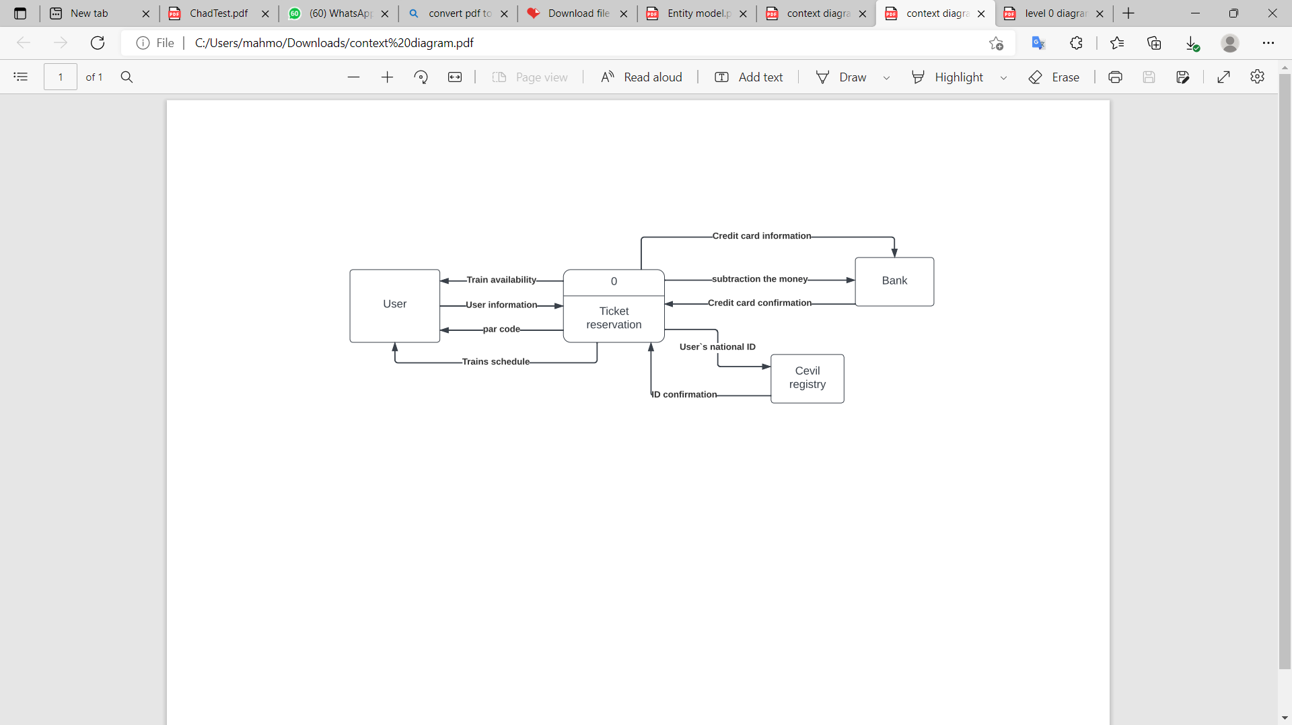

- Level 0:

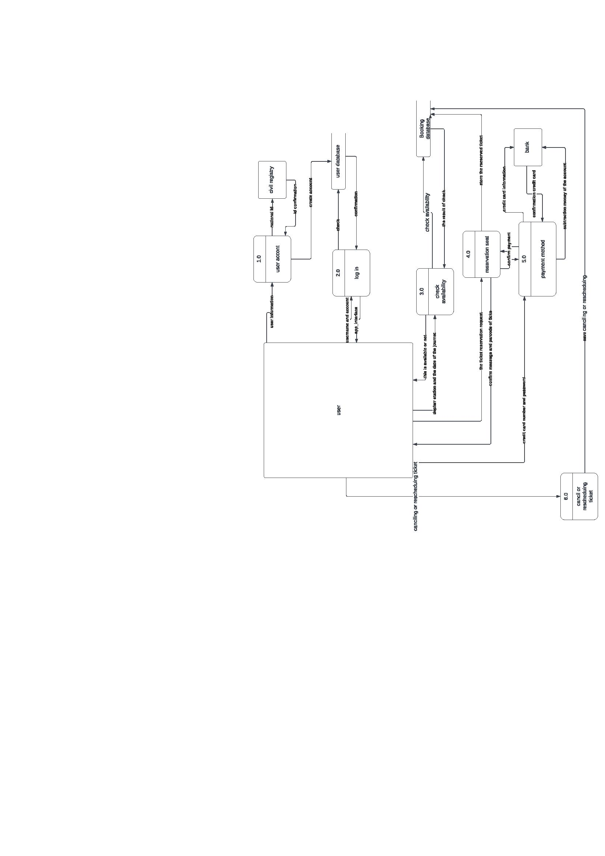

- Level 1:
- Process Model (1):
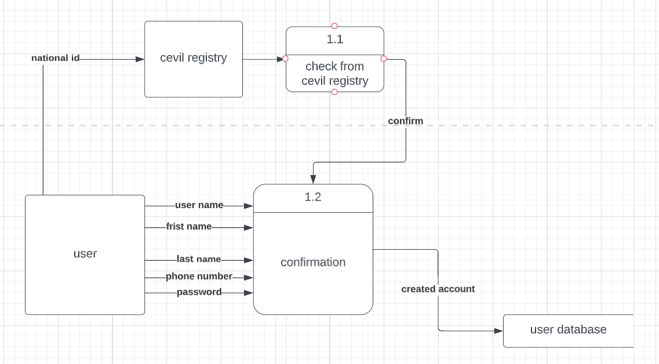
- Process Model (2):
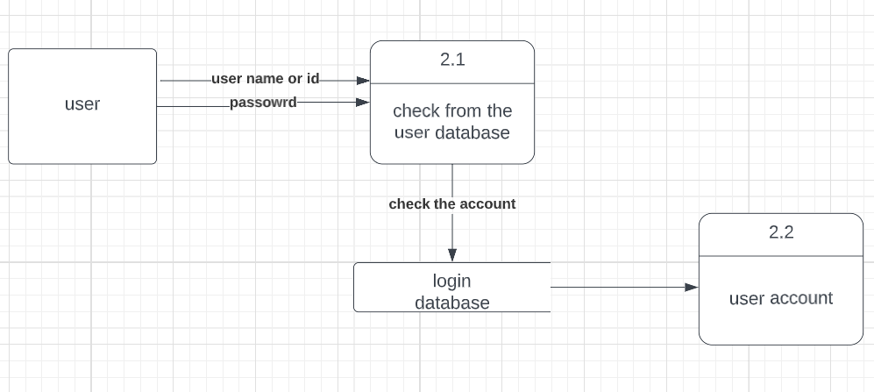

- Process Model (3)
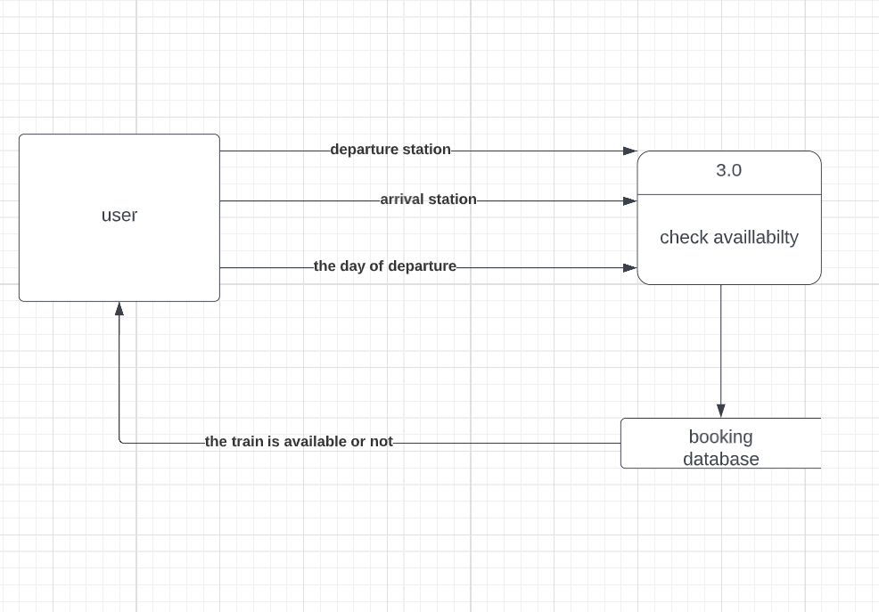
- Process Model (4):
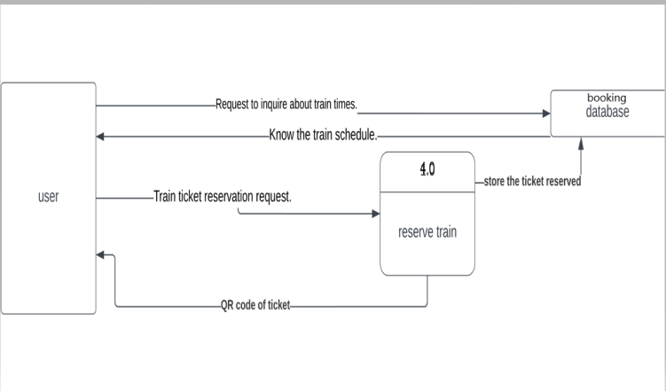
- Process Model (5):
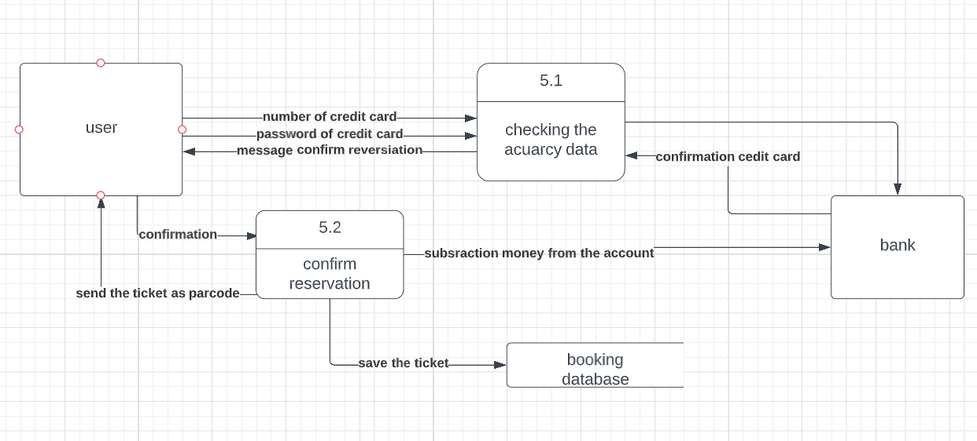

- Process Model (6):
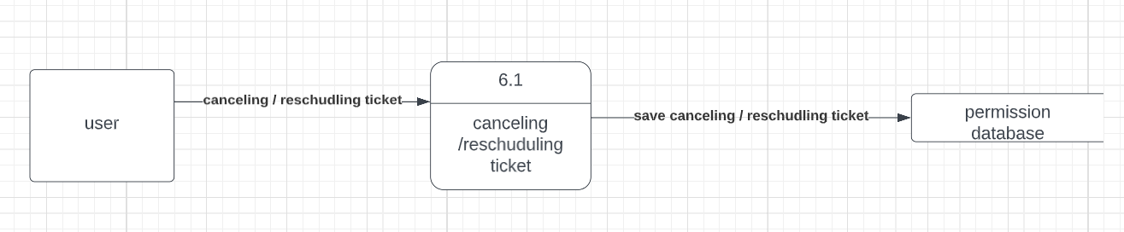

The Data Model

Entity model diagram :
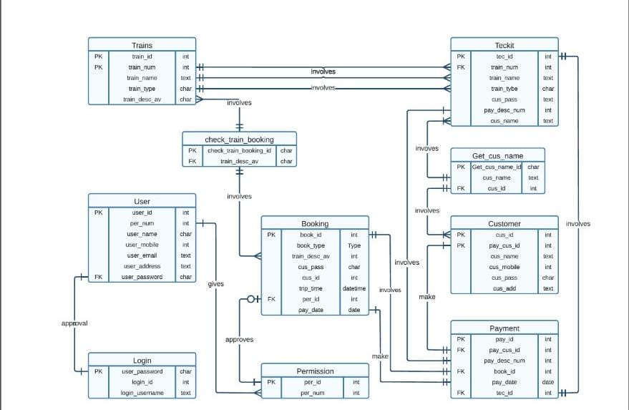

Team members:
1.مصطفى محمود محمد خليفه
2.محمود شحاته جابر اسماعيل
3. مصطفى اشرف على احمد
4. مصطفى محمود رجب حسن
5. مصطفى محمد احمد فؤاد
6. مصطفى حموده محمد رمضان
7. مصطفى رجب صابر مسلم

Section: 6
Group: 2

